**India’s New Education Policy, A Study of Impact on Economy**

Dr. Dinesh Kumar Gupta

Assistant Professor, Department of Economics

Government Degree College Banbasa (Champawat)

Email: economicsdkg@gmail.com

**Abstract**

*The National Education Policy (2020) seeks to obtain transformational reforms in school and higher education, shaping India into a global knowledge superpower. The Union Cabinet, chaired by PM (Prime Minister Shri Narendra Modi), supported the National Education Policy 2020 on July 29, 2020. This policy replaced the 34-year-old National Policy on Education (NPE) 1986. This policy opposes building the foundational pillars of Access, Equity, Quality, Affordability, and Accountability. Also, this policy aligns with the 2030 Agenda for Sustainable Development. The National Education Policy (NEP) aspires to transform India into a vibrant knowledge society and global knowledge superpower by making both school and college education more holistic, flexible, multidisciplinary, suited to 21st century needs and desired to bring out the unique abilities of each student. The new policy replaces the earlier National Policy on Education, 1986. The guideline is a complete framework for elementary education, higher education, and vocational training in rural and urban India. The policy seeks to transform India's education system by 2021. The primary objective of this analysis is to investigate the impact of the New Education Policy 2020 on higher education. The study outlines the salient features of NEP and analyses how they affect the existing education system.*

**Keywords**- NEP, New Academic Structure, Multidisciplinary Education.

**Introduction-**

Education is essential for the overall expansion of an individual. Therefore, the education policy must be changed with duration to maintain the quality of education. National Education Policy 2020 has also been obtained to support the country's education system effectively according to demand and need. The transformation in education policy occurred after 34 years. Before this, the year 1968 and the year 1986, third time there has been a shift in the National Education Policy. The current new education policy has been created under the chairmanship of Dr. K. Kasturirangan, former ISRO chief, and has been implemented after getting approval by the Union Cabinet headed by Prime Minister Sri Narendra Modi. The Committee introduced its report in May 2019 and addressed the challenges such as **access, equity, quality, affordability, and accountability** encountered by the current education system. The new education policy aims to pave the way for transformational reforms in India's school and higher education systems. Under this policy, modifications have been driven to the school-to-college education policy. Also, "The Ministry of Human Resource Development" will now be known as "The Ministry of Education."

The idea of **"National Education Policy 2020 predicts an India-centric education system that contributes directly to transforming our nation sustainably into an equitable and vibrant knowledge society by providing high-quality education to all."**

Under the New Education Policy 2020, the educational system has to be fixed by 2030, and the curriculum will be divided based on the educational system of **5+3+3+4** in place of the 10+2 model presently underway. A target of central and state governments has even been assigned for the New Education Policy 2020, in which the central and state government will support the education sector equal to 6% of the country's GDP for education sector cooperation.

**Objectives of the study**-

1. To understand the impact of the new education policy on the higher education system.
2. To study the outline of salient features of the NEP, challenges, and implementation.

**Research methodology**-

This research paper is descriptive and based on secondary data. The qualitative paper information was collected from various websites, including Government of India periodicals, press reports, other publications, research papers, and journals. The data was analyzed and reviewed to find an inevitable conclusion.

**Result & Discussion-**

**The Basic principle of the new education policy:**

The essential regulations that will guide both the education system broadly, as well as the individual institutions within it are mentioned below:

1. Accepting, Associating, and Nurturing the distinctive qualitative potential of each student by sensitizing teachers as well as parents to encourage each student's holistic development in both academic and non-academic globes;
2. Based on the highest priority to achieve Foundational Literacy and Numeracy for all students by Grade 3.
3. There should be some flexibility so that students can choose their learning courses and programs.
4. Strictly imposed divisions between arts and sciences, curricular and extra-curricular activities, and vocational and academic streams destroy hierarchies among them.
5. Interdisciplinary and comprehensive education across the sciences, social sciences, arts, humanities, and sports for a multidisciplinary world provides the harmony and integrity of all knowledge.
6. Better focus on the importance of conceptual understanding rather than rote learning and learning-for-exams;
7. Additionally focused on innovative and evaluative thought strategies to encourage logical decision-making and innovation to enhance qualitative learning;
8. Encouraging multilingualism and the power of language in teaching and learning;
9. Large-scale process of applied science method will be activated teaching and learning, terminate language barriers, increase access for *Divyang* students, and educational planning and management;
10. High consideration for diversity and respect for the restricted context in all curriculum, pedagogy, and policy, preserving that education is a concurrent subject;
11. A 'light but tight' normative structure to ensure integrity, transparency, and resource efficiency of the educational system in India for autonomy, good governance, and empowerment;

**Main Features of New Education Policy-**

1. Quality technology-based options for developing higher education, such as high-quality technical apps, availability of online courses, uses of satellite-based TV channels, online books, ICT-equipped libraries, and adult education centres will be developed. The e-content will be made available in regional languages ​​starting with eight languages ​​- Kannada, Odia, and Bengali possessed in the e-courses available in Hindi and English.

2. Through a newly established law, 100 foreign universities of the world's top quality will be allowed and facilitated to operate in India for work in the higher education system. According to the HRD ministry document, such (foreign) universities will be offered extraordinary relaxation regarding regulatory, governance, and content norms at par with other autonomous institutions in India.

3. The objective of board examinations is to encourage the student's holistic development and to test inner strength and abilities. Students can take board exams on two occasions during any school year, one for the main exam and one for improvement if desired. Students will appear in class 3, 5, and 8 school examinations conducted by the appropriate authority. The board exam will be performed in two parts - objective and descriptive.

4. The new education policy covers a bachelor's degree of 3 or 4 years. Mid-term dropouts will be granted credit with the option to complete the degree after the break

5. Major reforms in the field of the higher education system include a target of 50% Gross Enrollment Ratio (GER) by the year 2040 and provisions for multiple entry and exit.

6. National Testing Agency (NTA) will conduct the Common College Entrance Exam annually.

7. The admission and exam fees will be appointed within the regulatory framework, and no additional charges will be charged beyond the ceiling.

8. M.Phil courses will be closed under the new policy. All UG, PG, and Ph.D. courses will be interdisciplinary.

9. Research and innovation are the two main pillars of the development of the economy and society. The committee proposed an autonomous body National Research Foundation (NRF), to strengthen the research system. The primary function of the Foundation is to fund research in all disciplines. The NRF will have four central departments: Science, Technology, Social Sciences, and Arts and Humanities.

10. The 10+ 2 structure would be given as the 5+3+3+4 models. It will be enforced as follows-

* **Primary Stage-** It is split into two parts, three years of Pre-School or Anganwadi, followed by Classes 1 and 2 in Primary School. It will include children in the age group of 3-8 years. The main focus of the studies will be on activity-based learning.

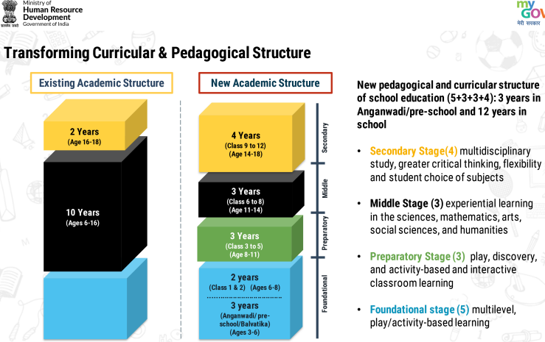

Source: MHRD GOI

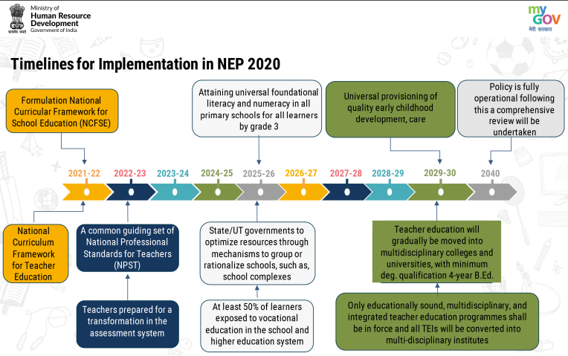Source: MHRD Government of India

* The preliminary stage consists of classes 3 to 5, involving children aged 8-11 years. Gradually the subjects like speaking, reading, writing, physical education, language, arts, science, and mathematics will be introduced.
* The middle stage will cover children in the age group of 6 to 8, 11 to 14 years. Students will be presented with more abstract concepts in mathematics, science, social sciences, arts, and humanities.
* **Secondary stage** in which classes 9 to 12 cover the age group of 14-19 years. It is similarly divided into two parts; classes 9 and 10 cover the first stage, while classes 11 and 12 covers the second stage. These four years of study aim to develop in-depth, critical thinking and multidisciplinary study. Multiple choices of subjects will be provided.

1. All students will participate in short 10-day periods, sometimes during grades 6-8, where they do internships with local business experts such as carpenters, gardeners, potters, and artists. Similar internship opportunities are provided for learning business subjects. For students in grades 6-12 throughout, including vacation periods. Vocational courses will also be made available through online mode. Bagless days will encourage throughout the year for various enriching activities, including arts, quizzes, sports, and commercial crafts.

**Provisions on the higher education system-**

Under the NEP-2020, a target has been formed to increase the 'Gross Enrollment Ratio' in higher educational institutions from 26.3% (the year 2018) to 50%, with this target will be added 3.5 crore new seats new in higher education institutions. Under the NEP-2020, the multiple entries and exit system has been adopted in the undergraduate course, in which the students in the undergraduate program of 3 or 4 years will be able to leave the course at multiple levels, and they will be awarded the degree or certificate accordingly (Certificate after one year, Advanced Diploma after two years, Bachelor's degree after three years and Graduation with research after four years).

 An 'Academic Bank of Credit' will be given to digitally secure the marks or credits obtained from different higher educational institutions so that they can be granted degrees based on students' performance in different institutions. Under the new education policy, the M.Phil program has ended. For IITs and IIMs, a Multidisciplinary Education and Research Universities (MERU) will be designated for global standards in India.

**Higher education commission of India:**

The New Education Policy (NEP) envisages a single regulatory body for higher education institutions across the country. The Higher Education Commission of India (HECI) will have multiple verticals to fulfil different roles. The Higher Education Commission of India will function as a single body for the absolute higher education sector excluding medical and legal education.

**Four bodies for effective execution of the functions of HECI-**

1. **National Higher Education Regulatory Council (NHERC):** It will act as a regulator for the higher education sector, including teacher education.
2. **General Education Council (GEC)** will prepare the framework of expected learning outcomes for higher education programs.
3. **National Accreditation Council (NAC):** It will undertake accreditation of institutions based mainly on basic norms, public self-disclosure, good governance, and other effective outcomes.
4. **Higher Education Grants Council (HGFC):** This body will do the work of funding colleges and universities.

**Impact of NEP 2020-**

**Impact on Students:**

NEP 2020 will pave the way for new excellent learning opportunities for the students. Due to this, there will be a change in the learning environment and learning process for the students. It will enable the students to concentrate on both academic and non-academic activities. There will be many learning opportunities for the students through pre-primary, open, and distance education. The Ministry of Education is trying to focus on India's image as an education hub as there are already more than 7 lakh Indian students studying abroad. Therefore, this policy intends to allow foreign universities to provide world-class education at a much lower cost locally without travel and significantly reduce human capital going to other countries for study and job prospects. Will come? Students will have access to counselling and other services. Therefore, this new National Policy on Education will also provide multiple exit options for mid-term drop-out students with 1-year training or 2-year diploma. With so many diverse opportunities, the curiosity and confusion of the students will also increase. Hence, they are also recommended to take the help of experts and professionals in making the right career decision.

**Impact on Teachers:**

The Government of India has decided to equip its teachers with more efficient and futuristic teaching skills. It is tracking the effects of the new policy on teachers.

* Teachers will be instructed in professional teaching standards.
* Teachers will be liable to clearly defined roles and responsibilities.
* The training facility will be provided for monitoring and improvement of the abilities of teachers from time to time.
* Transparent recruitment and selection process will be pursued to motivate the teachers and improve their performance.

It has been clarified in the new education policy that unless the country's teachers are satisfied, there will be no justification for opening thousands of colleges and universities in the country. Therefore, the ministry has decided that new educational institutions will be opened in the country only when the department has enough teachers. Before opening new institutes, the department will also ensure that the amenities of teachers in the area are available. Also, under the new education system, more emphasis is on the training of teachers, length of service, salary allowances, promotion, residential facilities, and other facilities.

**Challenges in implementing New Education Policy-**

1. **Opening new universities and colleges is a more difficult task**- As per AISHE-2019, there are 3.74 crore students in 993 universities, 39,931 colleges, and 10,725 stand-alone institutions in the higher education sector in India. Thus, the nationwide implementation of this comprehensive education policy is going to be of massive size. To increase the Gross Enrollment Ratio (GER) in higher education by 2035, many new universities will have to be extended in the next 20 years, which will be very challenging.

2. **Lack of resources for rural children** - The objective of this reform of the Indian education system is that no child will be denied education. The journey of education for rural areas is not easy; children from rural areas have to face many challenges till they complete their education.

**3. Difficulty in accessing advanced technical teaching equipment** – ​​Students in rural area schools either do not have access to or do not have access to digital learning, computer education, and other advanced teaching tools.

**4. Financial crisis -** Under the Right to Education Act, children are given free education until they are 14, after which they are out of RTE. Families in rural areas remain under financial burden. Education becomes a second priority for their children, so they are forced to do income-generating activities for survival.

**5. Lack of Infrastructure-** The creation of new infrastructure would be a tedious task that would require massive investment and take a long time to implement.

**6. Accelerating the development of digital infrastructure-**

As distance learning and technology-assisted education delivery are anticipated to become the new normal in a post-Covid world, huge investments are needed to develop digital infrastructure such as digital classrooms, distance expertise-driven learning models, and AR/VR equipment.

**7. Need to develop Anganwadi Centers and Primary Schools**- No doubt this is a good step, but if one looks at the infrastructure, facilities, and workforce of Anganwadi Centers.

**8. Requirement of trained staff-** There is a need to create a large pool of trained teachers. The policy envisages a comprehensive structural redesign of the curriculum in school education, which is a welcome step. However, to deliver this curriculum effectively, we need trained teachers who understand the educational needs.

**9. Role of the Private Sector-** The role of the private sector, especially in dealing with the higher education system, is of utmost importance to translate the inclusive approach of the NEP. It may be noted that the private sector runs 70 per cent of higher education institutions (colleges and universities). It may be mentioned that around 65-70 per cent of the students are registered in private higher education institutions. In addition, the private sector brings much-needed financial resources and innovation.

**Conclusion**-

The new education policy aspires to promote an inclusive, participatory and holistic approach that considers lessons learned from field experiences, empirical research, stakeholder feedback, and best practices. It is a progressive change towards a more scientific approach to education. Indeed, this policy will help fulfil the child's potential – stages of cognitive development as well as their social and physical awareness. If implemented in real terms, the new structure can bring India to par with the world's leading countries. This policy is anticipated to bring a positive and long-lasting impact on the **country's higher education system**. This policy presently shows the complete picture of the country. The government has to strengthen the educational infrastructure to achieve every objective of the new education policy. The capital pool of the country will have to be improved by increasing foreign direct investment (FDI). Indeed, the country needs more finance to attract talented teachers and build better infrastructure. The key to its success is its implementation within the stipulated time frame.

**References-**

* Aithal P. S. & Aithal Shubhrajyotsna (2020). Promoting Faculty and Student-Centered Research and Innovation-based Excellence Model to Reimage Universities. International Journal of Management, Technology, and Social Sciences (IJMTS), 5(1), 24-41. DOI: <http://doi.org/10.5281/zenodo.3702399>.
* Aithal, P. S. & Shubhrajyotsna Aithal, (June 2020). Conceptual Analysis on Higher Education Strategies for various Tech-Generations. International Journal of Management, Technology, and Social Sciences (IJMTS), 5(1), 335-351. DOI: <http://doi.org/10.5281/zenodo.3940590>.
* Bouhajeb, M., Mefteh, H., & Ammar, R. B. (2018). Higher education and economic growth: the importance of innovation. Atlantic Review of Economics, 1(2), 4.
* Deb, P. (2020). Vision for Foreign Universities in the National Education Policy 2020: A Critique. Rajiv Gandhi Institute for Contemporary Studies, 1-29. https://www.rgics.org/wpcontent/ uploads/Foreign-Universities in India-Palash-Deb.pdf
* Final National Education Policy 2020 (PDF) (Report). Ministry of Human Resource Development.
* Gohain, Manash Pratim (31 July 2020). ["NEP language policy broad guideline: Government"](https://timesofindia.indiatimes.com/home/education/news/nep-language-policy-broad-guideline-government/articleshow/77272709.cms). The Times of India. Retrieved 31 July 2020.
* Govt. of India (2020). [https://www.education.gov.in/sites/upload_files/mhrd/files/ NEP Final English_0.pdf](https://www.education.gov.in/sites/upload_files/mhrd/files/NEP_Final%20English_0.pdf)
* Hiremath, S. S. (2020). Education In India: Impact of Globalisation And ICT. Blue Diamond Publishing.
* Jeebanlata Salam, Draft National Education Policy (NEP), 2019 and jingoistic nationalism, The People's Chronicle, 27 June 2019.
* M. M. Goel (2020): A View on Higher Education in New Education Policy 2020.
* Malhotra, Smriti (November 2019), "The Draft National Education Policy: A Distressing Attempt to Redefine India", Journal of the Gujarat Research Society, 21 (11)
* Maniar, Vikas (14 September 2019), "Overlooking the Idea of Common School in the Education Policy" (PDF), Economic and Political Weekly, 54 (37) 18–19
* Nandini, ed. (29 July 2020). "New Education Policy 2020 Highlights: School and higher education to see major changes". Hindustan Times.
* National Education Policy 2020. [https://www.mhrd.gov.in/sites/upload files/mhrd/](https://www.mhrd.gov.in/sites/upload%20files/mhrd/) files/nep/NEP Final English.pdf referred on 10/08/2020.
* Puri, Natasha (30 August 2019). A Review of the National Education Policy of the Government of India - The Need for Data and Dynamism in the 21st Century. SSRN.
* Saha Mushkan (2020). National Education Policy 2020, International Journal of Research (IJR)
* Silova, I., Rappleye, J., & Auld, E. (2020). Beyond the western horizon: rethinking education, values, and policy transfer. In Handbook of Education Policy Studies (pp. 3-29). Springer, Singapore.
* Sunil Kumar Saroha, & Uttam Anand (2020). New instruction procedure 2020 Highlights: To see huge movements in schools and advanced edification. IOSR Journal of Humanities and Social Science (IOSR-JHSS), 25(8) 59-62.
* Vedhathiri, Thanikachalam (January 2020), "Critical Assessment of Draft Indian National Education Policy 2019 concerning National Institutes of Technical Teachers Training and Research", Journal of Engineering Education.